The Common Model of Cognition with Metacognition: A Guide to the Lean Specification
Nov 9, 2026 · @John Laird

Purpose and sources
This guide explains, in plain English, the Lean 4 specification CMC_Meta.lean: the Common Model of Cognition (CMC) extended with metacognition. It follows the specification's structure but leaves out the Lean code; every claim here corresponds to a definition or a proved theorem in the file.
The specification extends CMC.lean, the formalization of the 2017 Standard Model, which it leaves unchanged so that both versions remain available. It formalizes three sources:
- [LLR17] Laird, Lebiere and Rosenbloom (2017), A Standard Model of the Mind, AI Magazine 38(4).
- [RLL17] Rosenbloom, Laird and Lebiere (2017), Précis of 'A Standard Model of the Mind', Advances in Cognitive Systems.
- [LLRS] Laird, Lebiere, Rosenbloom and Stocco, Unified, Comprehensive Metacognition within the Common Model of Cognition, AGI (final version).
The specification marks the status of each point. This guide keeps the same labels:
Label | Meaning
DECIDED / CONFIRMED | A clarification by John Laird, with its date. Decisions of 2026-10-28 about metacognition are marked [META].
OPEN | Not settled by the papers.
FUTURE | A planned extension.
VARIANT | A permitted architectural variation, recorded but not formalized.
NOT FORMALIZED | Recorded only.
The sections run from the big picture, through the building blocks and working memory, to each module, the processing cycle, and the guarantees proved about the whole.

The big picture
The extension adds no metacognitive module: it makes every module report on its own processing in working memory, and metareasoning is ordinary reasoning over those reports.
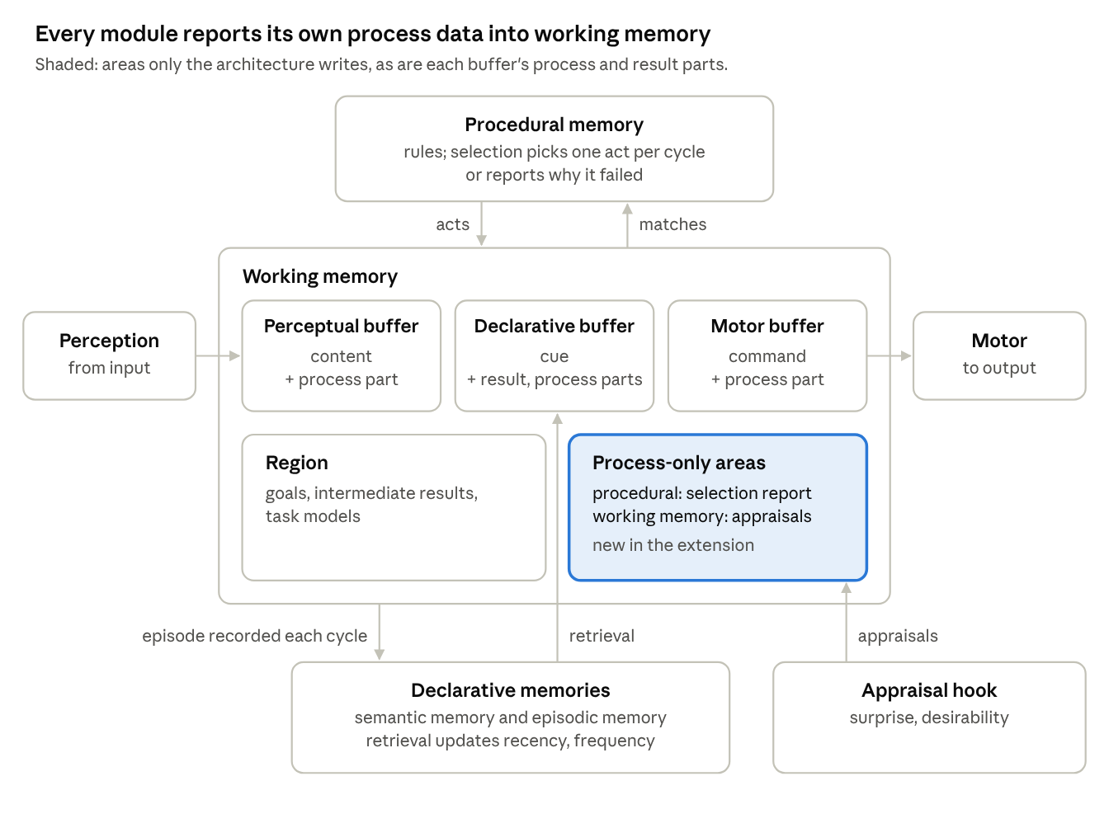
CMC with metacognition · modules, buffers and process-only areas
As in the 2017 model, all modules communicate through working memory, and procedural memory selects one act per cycle. The extension adds two structural changes, in [LLRS]'s words "module process-state buffers and episodic memory":
- A process-data area for every module, written only by the architecture.
- Selection reports why it failed (no candidates, tie, conflict, no progress) instead of being silent.
- Episodic recording of working memory on every cycle, into a designated declarative memory.
- Retrieval updates the metadata (recency, frequency) of what it retrieves.
- A working-memory appraisal hook for task-independent appraisals such as surprise.
What it deliberately does not add:
"metacognition requires no dedicated metacognitive reasoning modules: it reuses the CMC's existing cognitive capabilities" — [LLRS] abstract
Metareasoning is carried out by the same cognitive cycle as base-level reasoning. The specification proves this (see Guarantees).

Basic building blocks
Everything the architecture stores is a symbolic relation carrying numeric metadata; rules can see the symbols but never the numbers.

The signature: what each architecture supplies
The specification is generic. A particular architecture (Soar, ACT-R, Sigma) fills in a signature of types:
Item | What it is
Symbols, values | The vocabulary of symbolic content, and the values metadata can take.
Perceptual modules, motor modules | The architecture's input and output modules, any number of each.
Declarative memories | One or more long-term declarative memories.
Episodic memory (epi) | The declarative memory designated to receive episodic recordings.
Input, output | What arrives from the environment and what is sent to it.
Learning state | The internal state of perceptual and motor learning.
Metadata kinds | A fixed set that includes utility, frequency and recency.
[META] DECIDED (Laird, 2026-10-28): be conservative and allow either two declarative memories or one that supports episodic functions. With separate semantic and episodic memories and epi set to the episodic one, the arrangement is Soar's. With a single declarative memory that also records episodes, it is Sigma's (and partly ACT-R's).

Relations, elements and metadata
- Relation: a predicate symbol with a list of argument symbols. This is the symbolic content of working memory and of declarative memory.
- Metadata: numbers attached to an item, one optional value per metadata kind (for example utility, frequency, recency).
- Element: a relation together with its metadata. Working memory and declarative memory both hold elements.
DECIDED (2026-10-28): metadata is numeric and cannot be examined by rules. Rules match only the symbolic content. Process data (described under working memory) may still include symbols that stand for graded values, such as a level of surprise.

Working memory
Working memory is divided into locations: buffers for each module, a free region, and new process-data areas that only the architecture may write.

Locations
Location | Parts | Who writes it
Perceptual buffer (one per perceptual module) | content: what is perceived | perception
 | process: perception's process data | architecture only
Declarative buffer (one per declarative memory) | cue: what to retrieve | deliberate reasoning
 | result: what was retrieved | architecture only
 | process: retrieval's process data | architecture only
Motor buffer (one per motor module) | command: what to do | deliberate reasoning
 | process: the motor module's process data | architecture only
Procedural process area | selection's report on each cycle | architecture only
Working-memory process area | task-independent appraisals | architecture only
Region | goals, intermediate results, task models; not tied to any module | deliberate reasoning
"Our first extension to the CMC provides partial access to the internal states of modules by expanding the existing buffers in working memory and adding new buffers for every module … these additional buffers hold architecturally generated data that summarizes each module's processing state." — [LLRS] §4.2

Process data
[META] DECIDED (Laird, 2026-10-28):
- Every module has a process-data area. Modules that already had buffers (perception, declarative memories, motor) gain a process part beside their existing parts. Procedural memory and working memory get buffers that hold only process data.
- Only the architecture writes process data. Procedural memory can never write it, and forgetting can never remove it.
- Each report replaces the previous one. Process data is a snapshot of the module's current state.
- Status signals live in process areas. Retrieval failure, confidence and partiality go in the declarative process part, so the result part holds only what was retrieved. Motor success or failure goes in the motor process part; the motor buffer has no result part.
- Process data may be graded. It can include symbols that denote graded values, as in surprise. Raw numeric metadata on memory elements is still never delivered to working memory.
The declarative result part is also architecture-written: like process data, deliberate reasoning cannot write it and forgetting cannot remove it.

What rules can see
Rules match working memory with the numeric metadata erased: two working memories with the same symbols satisfy the same rule conditions. Process data is symbolic, so rules can see it, and that is how metareasoning is triggered.
"The knowledge for monitoring is typically represented as procedural knowledge that tests for appropriate structures in working memory, matching alongside the rules for base-level reasoning within the same cognitive cycle." — [LLRS] §4

The modules
Each module reads and writes only its own parts of working memory, and each reports on its own processing in its process area.

Procedural memory and selection
- Content: a list of rules. Each rule has a condition on working memory, an action that changes working memory, and numeric metadata (such as utility). Every condition must ignore numeric metadata.
- Selection: on each cycle, selection examines procedural memory and working memory and returns either one deliberate act or a failure with its reason. In the 2017 model, failure was silent.
- Why selection can fail:
Reason | Meaning
No candidates | No action applies.
Tie | Several actions apply and there is not enough knowledge to choose between them.
Conflict | The knowledge about which action to choose conflicts.
No progress | The previously selected action is making no progress.
[META] DECIDED (Laird, 2026-10-28): all four reasons are in scope, including no progress.
- Report: after every cycle the architecture writes a report of the cycle's outcome, including any failure reason, into the procedural process area, replacing the previous report.
- Restriction: a selected act never changes an architecture-written location (any process area or declarative result).

Declarative memories: semantic and episodic
- Content: each declarative memory holds elements (relations with metadata).
- Retrieval: from the memory and the cue in its buffer, the architecture produces a result and process data: failure, confidence, partiality (for example, a tip-of-the-tongue state). The result goes in the buffer's result part, never in the region, which keeps retrieved past experience apart from the current situation.
- Metadata effect of retrieval: retrieving an item updates its metadata, such as recency and frequency. Retrieval never changes the symbolic content of declarative memory. [META] DECIDED (Laird, 2026-10-28).
- Episodic memory: episodic retrieval goes through the same retrieval step, applied to the episodic memory. [META] DECIDED: temporal navigation (the next or previous episode relative to the last one retrieved) is part of the extension, expressed through the cue and the episodic memory's own metadata.
- Episodic recording: on every cycle, the resulting working memory is recorded into the episodic memory as a new episode. Recording keeps every existing episode. Episodes can decay and be forgotten like any declarative content. Recording is not limited by the learning bound, since an episode is a snapshot of all of working memory. [META] DECIDED (Laird, 2026-10-28).
"Episodic memory automatically stores the contents of working memory as a temporal stream" — [LLRS] §4.3

Perception
From its learning state, the input and current working memory, each perceptual module produces what is perceived (its content part) and its process data: failure, novelty, surprise or incompleteness (for example, an occluded object that cannot be identified).

Motor
Each motor module turns the command in its buffer into external output. It also reports its status as process data: success or failure of execution, with the reason (for example, a grasp that slips because the object is heavier than expected). [META] DECIDED (Laird, 2026-10-28): all motor status is process data.

Working-memory appraisal
A hook produces task-independent appraisals of working memory and overall operation (for example, surprise or inherent desirability) and writes them into the working-memory process area. [META] DECIDED (Laird, 2026-10-28): the hook is kept and its content left abstract. FUTURE: the emotion proposal (Rosenbloom et al., ICCM 2024) would refine it.

Learning mechanisms
All learning works from the most recent cycle (working memory before and after it).
Mechanism | Changes | Restriction
Composition | adds new rules to procedural memory | at most a fixed number (the learning bound) per step; existing rules kept
Reinforcement learning | rule utilities | changes only the utility metadata; conditions and actions unchanged
Declarative creation | adds elements to a declarative memory | at most the learning bound per step; existing content kept
Declarative tuning | metadata of declarative elements | symbolic content unchanged
Perceptual and motor learning | each module's learning state | —
There are also decay (of working-memory and declarative metadata) and forgetting (removal of elements that the architecture judges forgettable from their metadata).

Overall processing
The architecture advances by steps; the cognitive cycle is the one step that carries out deliberate reasoning, for base-level reasoning and metareasoning alike.

The state of the architecture
At any moment the architecture's state consists of: working memory; procedural memory; each declarative memory; the last cycle (working memory before and after it, which learning uses); and the learning state of each perceptual and motor module.

The cognitive cycle
One cycle does three things in order:
- Select and apply. Selection returns one act or a failure. An act is applied to working memory; a failure leaves working memory unchanged.
- Report. The procedural process area is overwritten with the architecture's report of the outcome, including the failure reason if there was one.
- Record. The resulting working memory is recorded as an episode in the episodic memory, and the cycle (before and after) is remembered for learning.
There is no separate metacognitive step. Metareasoning happens when rules match process data (such as a tie reported in the procedural process area) and select acts that reason about it.

Other kinds of step
Step | Effect
Perceive | Writes a perceptual buffer's content and process parts.
Retrieve | Writes a declarative buffer's result and process parts from its cue; updates the retrieved items' metadata.
Motor | Sends output from the motor command; writes the motor process part.
Appraise | Writes the working-memory process area.
Perceptual learning, motor learning | Update a module's learning state.
Composition, reinforcement learning, declarative creation, declarative tuning | Learn from the last cycle (no effect before the first cycle).
Decay | Decays the metadata of every element in working and declarative memory.
Forget from working memory | Removes forgettable elements from one location; never from an architecture-written location.
Forget from declarative memory | Removes forgettable elements from one declarative memory.
DECIDED (2026-10-28): the theory assumes these processes run simultaneously; the specification interleaves them, one step at a time, as a modelling device. For reasoning about whole runs, each kind of step also has a label, and a run is a sequence of labelled steps.

Guarantees proved about the model
The specification proves the following properties for every architecture that fits it; each is a theorem checked by Lean, not an assumption.
Guarantee | In plain English | Theorem
Seriality, with reported failure | Outside the procedural process area, a cycle applies exactly the selected act, or changes nothing. | cycle_serial
Selection failure is reported | After a cycle, the procedural process area holds the report of the outcome, including any failure reason. | cycle_reports
No direct access to declarative memory | A cycle depends only on working memory and procedural memory. | cycle_independent_of_decl
Process data is ground truth | If a step changes an architecture-written location, that step was the location's own module reporting. No deliberate act can write process data. | arch_provenance
Process data is a snapshot | Retrieval, motor and appraisal reports each replace the previous report. | retrieve_replaces, motor_replaces, appraise_replaces
Retrieval changes only metadata | Retrieval never changes the symbolic content of any declarative memory. | retrieve_metadata_only
Every cycle records an episode | The episodic memory after a cycle is the recording of the cycle's resulting working memory. | cycle_records
Declarative content is removed only by forgetting | Any other step keeps every relation in a declarative memory, episodes included. | decl_content_kept
Metareasoning uses the same cycle | Only a cognitive cycle (or forgetting) changes the region, a retrieval cue or a motor command. There is no metacognitive module. | deliberate_only_by_cycle
Procedural memory changes only by learning | Only composition and reinforcement learning change procedural memory. | proc_change_is_learning
Acquisition requires a cycle | Before the first cycle, no step changes procedural memory or adds declarative content. | acquisition_requires_cycle
Declarative knowledge reaches behaviour only through retrieval | Two states that differ only in declarative memory (episodes included) behave identically along any sequence of steps without a retrieval. | decl_influence_requires_retrieval
Rule conditions are symbolic | A well-formed rule gives the same answer on two working memories with the same symbols. | match_ignores_metadata
Content is visible | Every element in working memory, process data included, is visible to rules. | content_visible
Consistency. The file also builds a minimal architecture that meets every requirement (two declarative memories, semantic and episodic; selection that always reports no candidates; a retrieval that reports failure as process data). This shows the requirements can all be satisfied together.

Variants, open points and glossary
Two points are recorded but deliberately left out of the formal model.
- Impasses and substates (VARIANT, not formalized). In Soar and Sigma, a selection failure creates a substate that holds information about the impasse, with the prior information kept in the top state. Substates can stack and are removed when the impasse is resolved. This keeps meta-level reasoning, including over retrieved episodes and hypothetical states, apart from the current situation. [LLRS] §5 presents this as one way to realize the extension, not part of it; conceptually, the substate is the procedural process buffer. [META] DECIDED (Laird, 2026-10-28).
- Derived information (not architectural). Self-observation, knowledge about other agents, and recorded information are ordinary content, acquired through perception and learning.

Glossary
Term | Meaning
Architecture-written location | A process area or a declarative result: written only by the architecture, never by rules, never forgotten.
Cognitive cycle | The step that selects and applies one act (or reports failure), writes the procedural report, and records an episode.
Element | A relation with its numeric metadata.
Episode | A recording of working memory after one cycle, stored in the episodic memory.
Metadata | Numbers attached to an element or rule, such as utility, frequency and recency; invisible to rules.
Metareasoning | Ordinary reasoning whose conditions test process data or other meta-information in working memory.
Process data | An architecture-generated snapshot of a module's processing state, held in its process area.
Region | The part of working memory not tied to any module: goals, intermediate results, task models.
Relation | A predicate symbol with argument symbols: the symbolic content of memory.
Selection failure | No candidates, tie, conflict, or no progress; reported each cycle.
Signature | The types a particular architecture supplies to instantiate the specification.

